Week 1: Skill

WSL Installation:
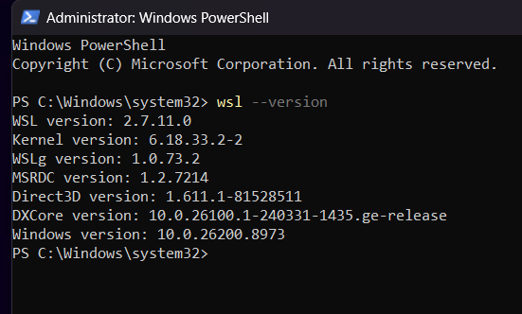

Report: It displays the installed version of Windows Subsystem for Linux (WSL),
The command displayed the installed WSL version (2.7.11.0), Linux kernel version, WSLg version, Direct3D version, DXCore version, and the Windows version, confirming that WSL is installed and working properly.
Simple Commands:
1.pwd
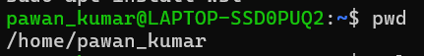
Report: It displays the current working directory. The command(pwd) returned output as /home/pawan_kumar indicating that the user is currently in the home directory.

2. Clear:
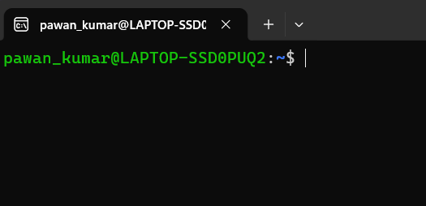
Report: It clears the terminal screen by removing the previously displayed commands and output. The command (clear) successfully cleared the terminal, providing a clean workspace for entering new commands.

3. History:
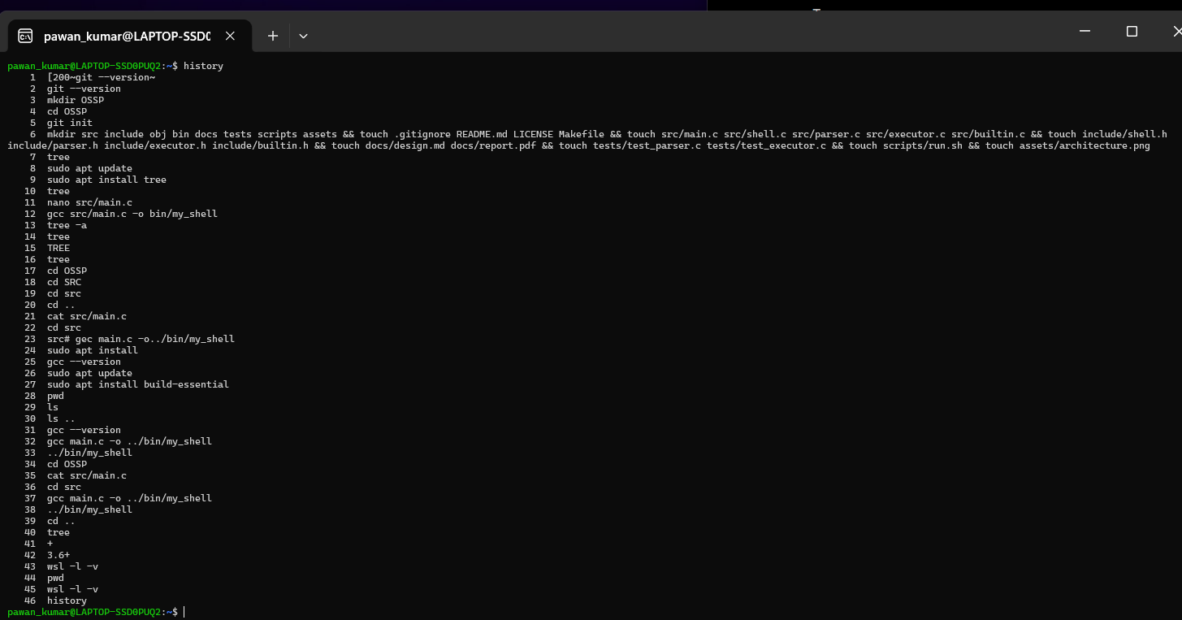

Report: It displays the list of previously executed commands. The command (history) returned the history of commands that were executed in the current terminal session.
4. Whoami:
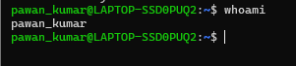
Report: It displays the currently logged-in username. The command (whoami) returned the username pawan_kumar.
5. Date:
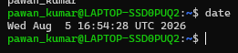
Report: It displays the current system date and time. The command (date) returned the current date and time of the system, that is Aug 5th.
6.Cal:
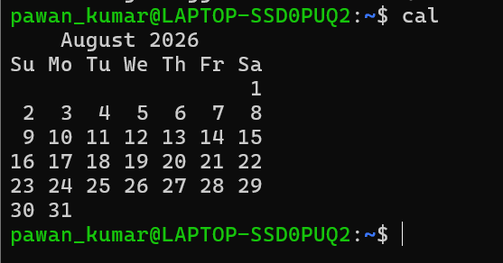
Report: It displays the calendar of the current month. The command (cal) returned the calendar for the current month that is August month calendar
7. Hostname:
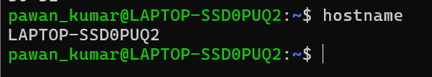
Report: It displays the system hostname. The command (hostname) returned the hostname as LAPTOP-SSDOPUQ2.

8. Uname -a:
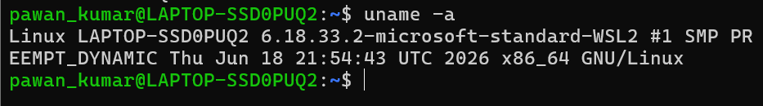
Report: It displays detailed operating system information. The command
(uname-a) returned the Linux kernel and system details.

9.Exit:
Report: It exits the terminal session. The command (exit) closed the current terminal window.

TOPIC 2: Directory Management
1.Ls:
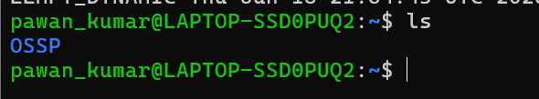
Report: It displays the files and directories in the current location. The command (ls) returned the list of available files and folders they are: OSSP, command_executor, command_executor.c

2.Ls -l:
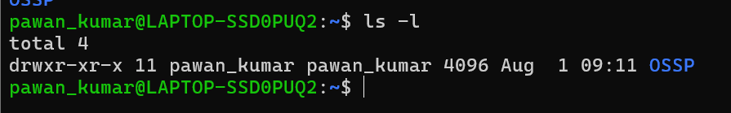

Report: It displays detailed information about files and directories. The command (ls -l) returned the permissions, owner, size, and modification date of each file.

3.Ls -a:
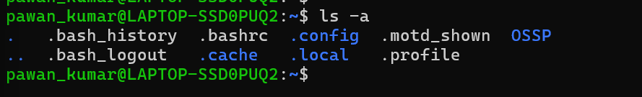
Report: It displays all files, including hidden files. The command (ls -a) returned both visible and hidden files in the current directory.
4.Cd:
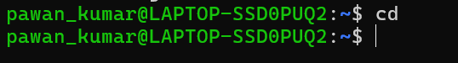
Report: It changes the current working directory. The command (cd) successfully changed the directory to the specified location.
5.cd ..
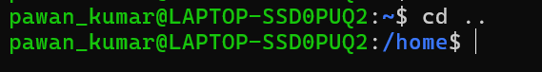
Report: It moves to the parent directory. The command (cd ..) successfully changed the current directory to its parent that is /home.
6.Mkdir:
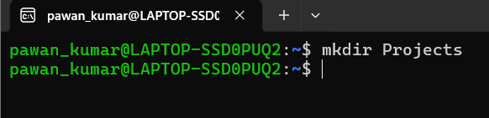
Report: It creates a new directory. The command (mkdir) successfully created the specified directory.
7.Rmdir:
Report: It removes an empty directory. The command (rmdir) successfully deleted the empty directory.
8.Find:

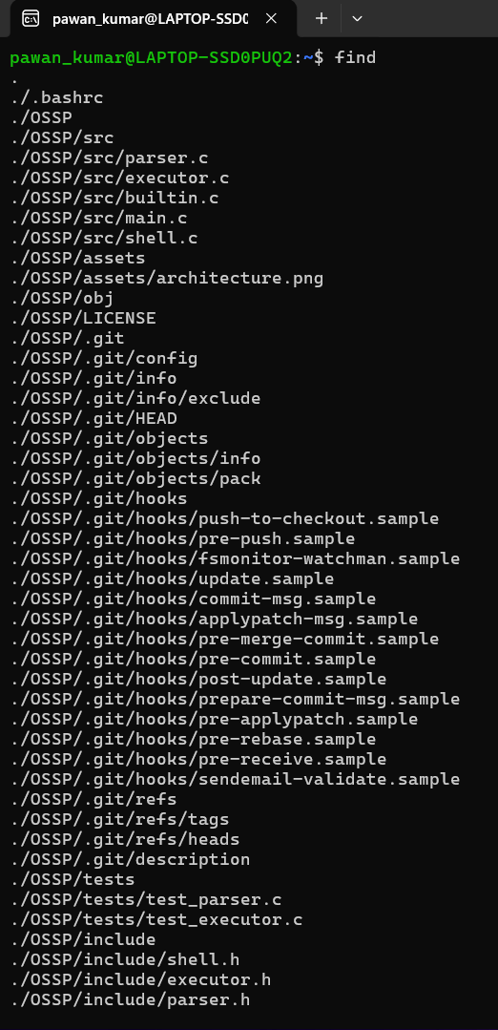
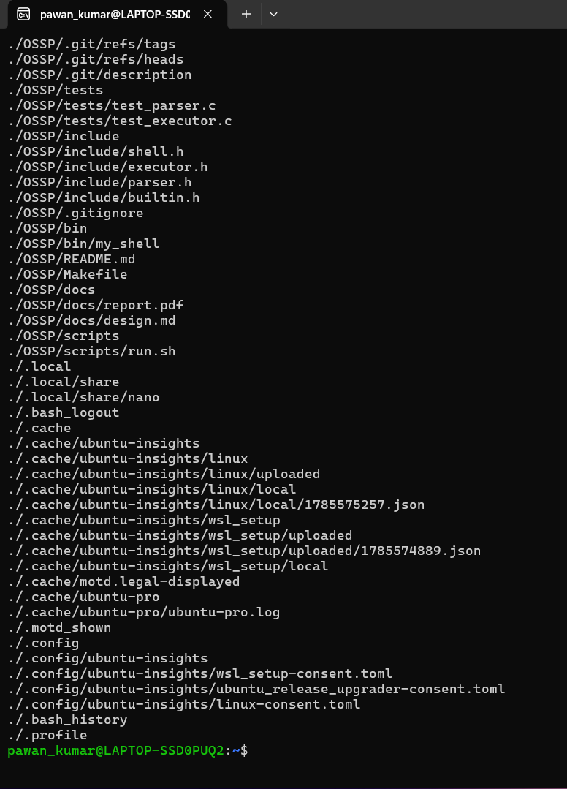
Report: It searches for files and directories. The command (find) returned the location of the specified file

9. Locate
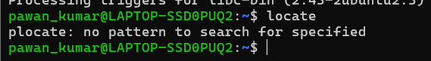
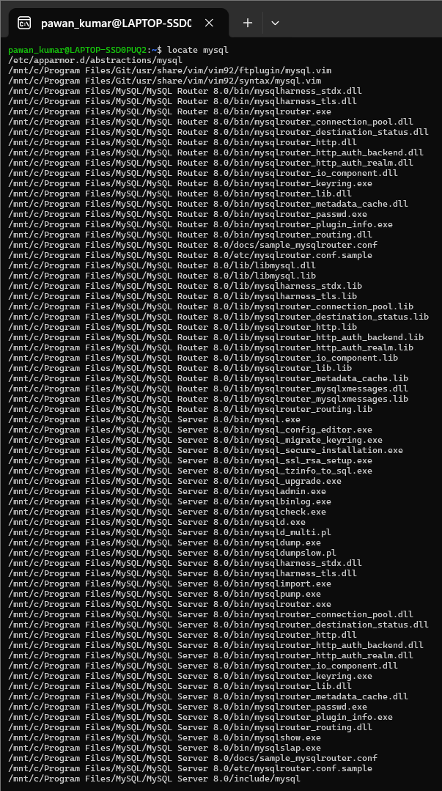
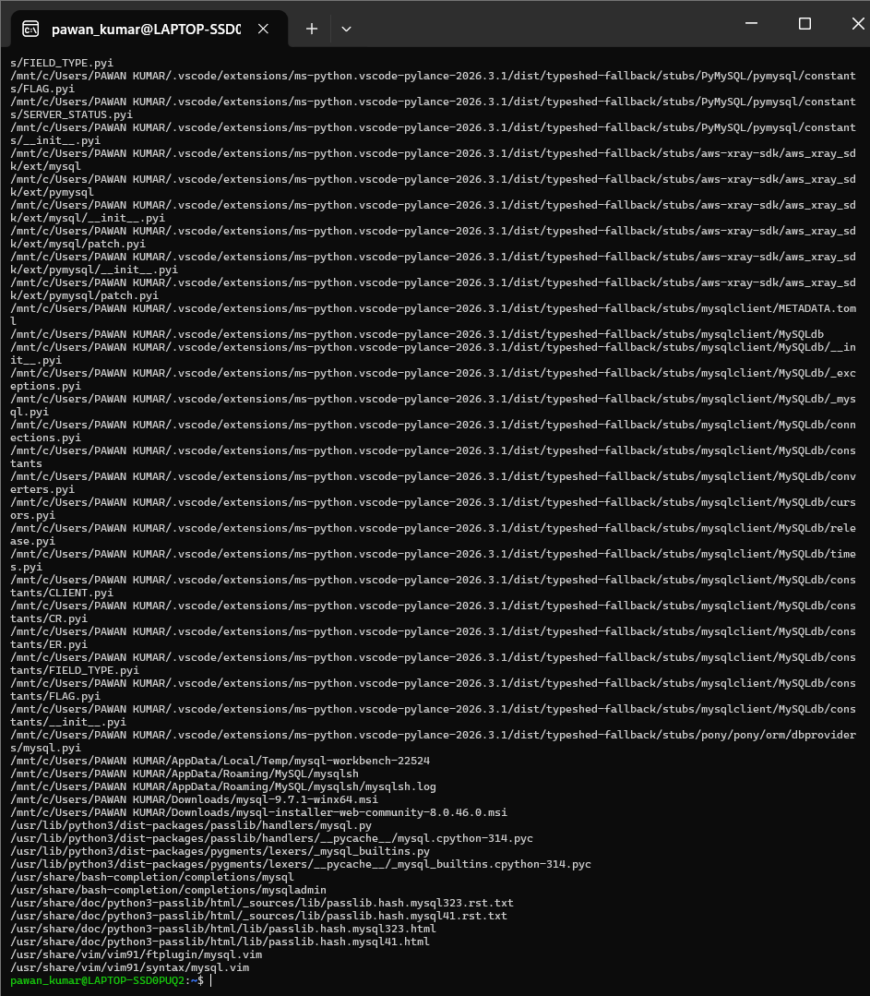
Report: It quickly searches for a file using the system database. The command (locate) returned the path of the requested file if it existed.

TOPIC 3: File Management
- Touch
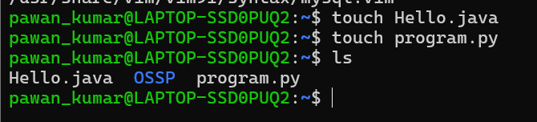
2.cat
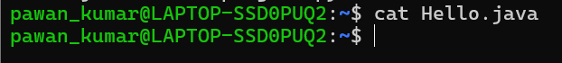
3.cp
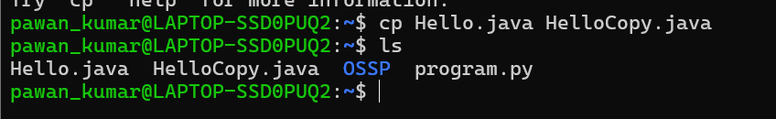
4.Mv:
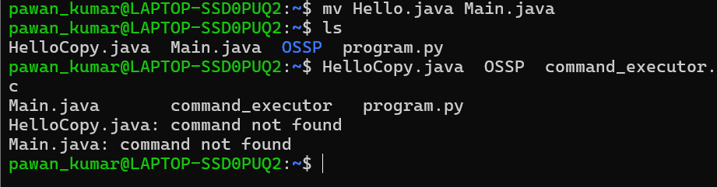
5.Rm:
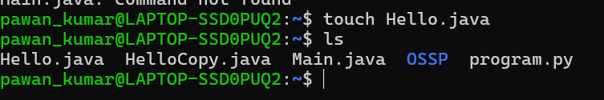

6.Less:
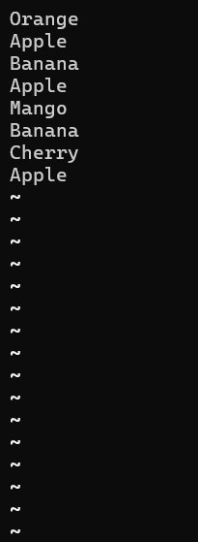
Report: It allows scrolling through a file. The command (less) displayed the file contents and allowed scrolling in both directions.
7.Wc:
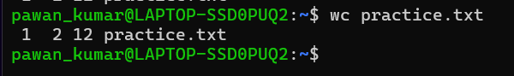 Report: It counts the number of lines, words, and characters in a file. The command (wc) returned these counts for the specified file.
8. Diff:
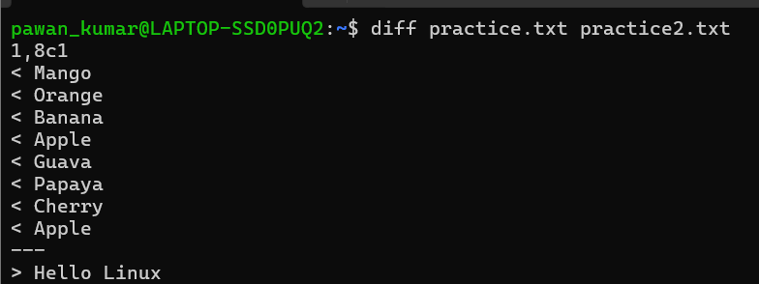
Report: It compares two files. The command (diff) displayed the differences between the specified files.
9.Sort:
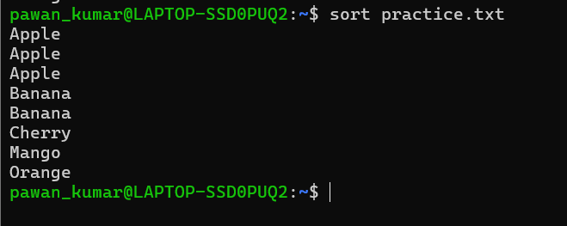
Report: It sorts the contents of a file. The command (sort) returned the file contents in alphabetical order.
10.Uniq:
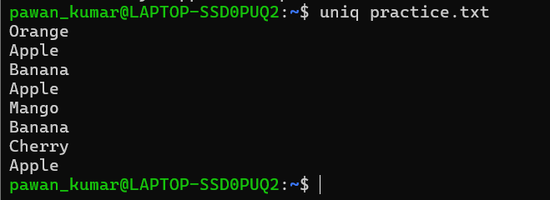
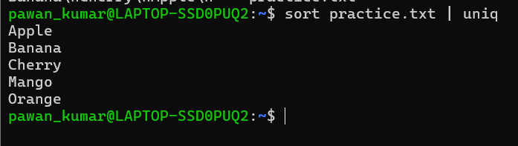
Report: It removes duplicate consecutive lines from a file. The command (uniq) returned the file contents without duplicate consecutive lines.
11.Grep:
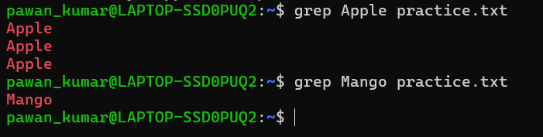
Report: It searches for a specific word or pattern in a file. The command (grep) displayed the lines containing the searched text.

TOPIC 4: File Editing
1.Nano:
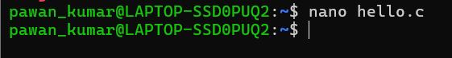
Report: It creates or edits a file. The command (nano) opened the specified file for editing.
2.Vi:
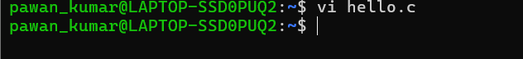
Report: It opens a file in the Vim editor. The command (vi) allowed the file to be edited and saved.
TOPIC 5: C Program Compilation and Execution

1.Gcc
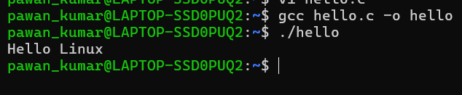

Report: It compiles a C program. The command (gcc) successfully compiled the program and created an executable file.
2./program: 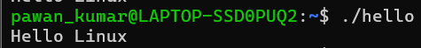
Report: It executes the compiled program. The command (./hello) successfully ran the program and displayed the expected output

3.Which:
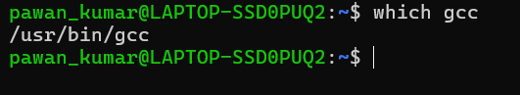

Report: It displays the location of an executable command. The command (which) returned the path where the command is installed.
4. Whereis:
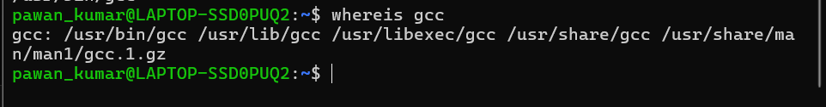
Report: It displays the binary, source, and manual page locations of a command. The command (whereis) returned the available locations for the specified command.
5.Man:
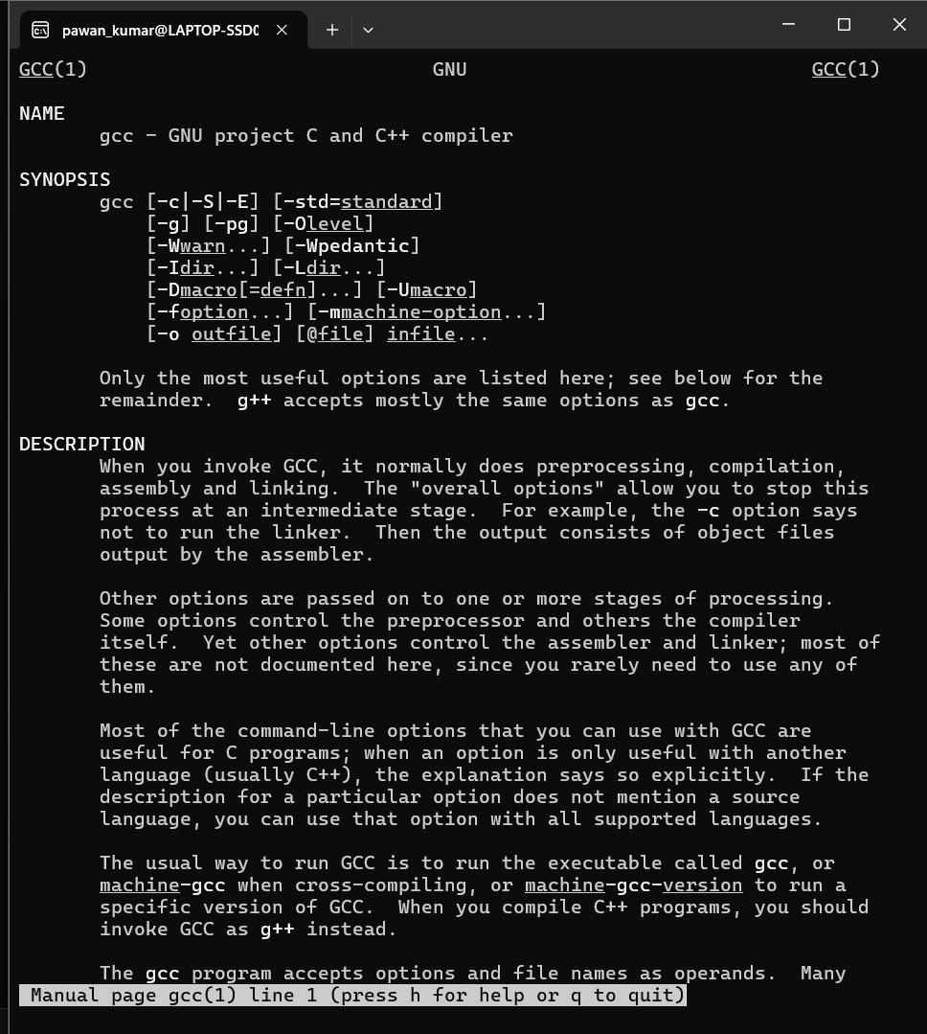
Report: It displays the manual page of a command. The command (man) opened the documentation for the specified command.

TOPIC 6: Process Management
1.ps:
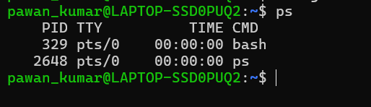
Report: It displays the currently running processes. The command (ps) returned the list of active processes
2.Ps -ef:
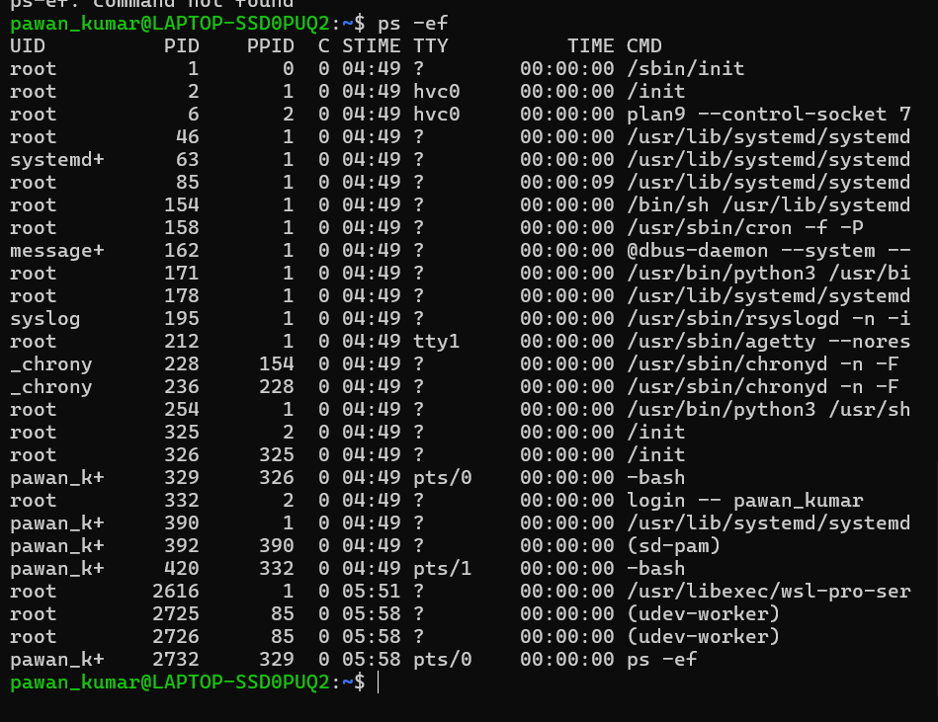
Report: It displays all running processes with detailed information. The command (ps -ef) returned the complete list of active processes.
3.Top:
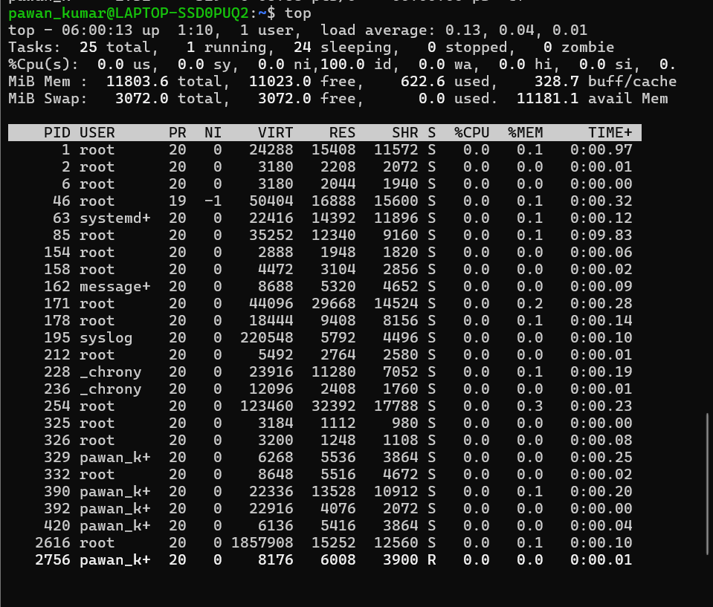
Report: It monitors the running processes in real time. The command (top) displayed the live process and system resource information.
4.Kill:
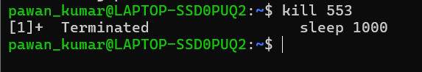
Report: It terminates a running process. The command (kill) stopped the specified process.

- Kill -9
Report: It forcefully terminates a running process. The command (kill -9) immediately stopped the specified process.

TOPIC 7: Job Controls

- Jobs
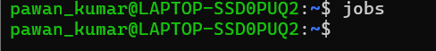
Report: It displays the jobs running in the background. The command (jobs) returned the list of background jobs currently running.
2.Bg:
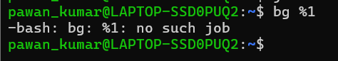
Report: It resumes a stopped job in the background. The command (bg) successfully resumed the selected job.
3.Fg:
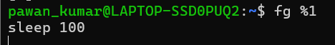
Report: It brings a background job to the foreground. The command (fg) resumed the selected job in the terminal.
4.&
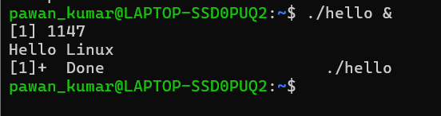
Report: It runs a command in the background. The command executed successfully and continued running while the terminal remained available.

